Based on the Entity-Relationship Diagram (ERD) for a tolling system, showing entities like TOLLRECORD, USER, VEHICLE, ACCOUNT, PAYMENT, CAMERA, and LOG, along with their relationships and attributes we have created the necessary Activity Diagrams for this system. To create activity diagrams for this tolling system, we need to identify the key processes or workflows that occur within the system We’ll outline the main processes that likely occur, such as vehicle detection, toll recording, payment processing, user account management, and logging activities. We’ll describe the activity diagrams also in a textual format. Each activity diagram will focus on a specific process within the tolling system.

1. Vehicle Detection and Toll Recording
This process involves a vehicle passing through a toll booth, being detected by a camera, and having a toll record created.
- Start: Vehicle approaches the toll booth.
- Action: Camera captures the vehicle’s plate number.
  - Decision: Is the plate number readable?
    - Yes: Proceed.
    - No: Log an error (e.g., "Unreadable Plate") and end process.
- Action: System retrieves VEHICLE details using PlateNumber.
  - Decision: Is the vehicle registered in the system?
    - Yes: Proceed.
    - No: Log an error (e.g., "Unregistered Vehicle") and end process.
- Action: System creates a new TOLLRECORD entry.
  - Attributes: TimeStamp, CameraID, VehicleID.
- Action: Update TOLLRECORD with Status (e.g., "Pending Payment").
- Action: Log the event in the LOG table (e.g., LogType = "Toll Recorded", Message = "Vehicle Passed").
- End: Toll record created successfully.

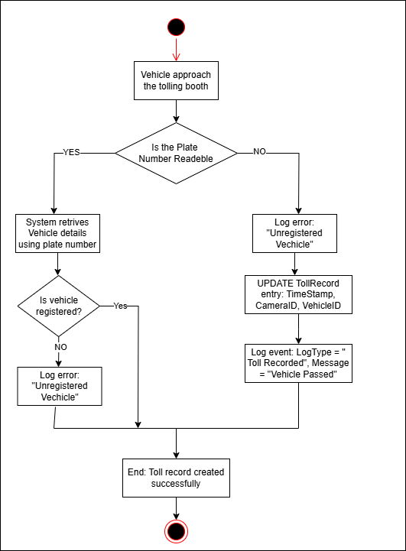

2. Payment Processing
This process handles how a toll payment is processed after a toll record is created.
- Start: System identifies a TOLLRECORD with Status = "Pending Payment".
- Action: Retrieve associated VEHICLE and linked USER via USERID.
- Action: Retrieve USER’s ACCOUNT details.
  - Decision: Does the account have sufficient BALANCE?
    - Yes: Proceed.
    - No: Notify user (via Email) to add funds and end process.
- Action: Calculate TollAmount for the TOLLRECORD.
- Action: Deduct TollAmount from ACCOUNT.BALANCE.
- Action: Create a new PAYMENT record.
  - Attributes: PaymentID, Method (e.g., "Account Deduction"), Amount, Date, Status (e.g., "Completed").
- Action: Update TOLLRECORD.Status to "Paid".
- Action: Log the event in the LOG table (e.g., LogType = "Payment Processed", Message = "Toll Paid").
- End: Payment processed successfully.
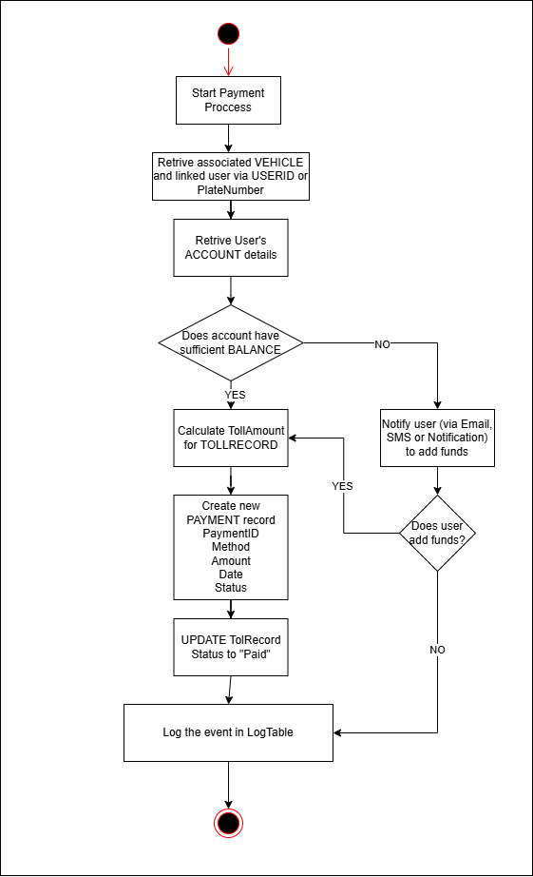
3. User Account Management (Add Funds)
This process describes how a user adds funds to their account.
- Start: User logs into the system.
- Action: System verifies USER credentials (e.g., Email, Role).
  - Decision: Is the user authenticated?
    - Yes: Proceed.
    - No: Log an error (e.g., "Authentication Failed") and end process.
- Action: User selects "Add Funds" option.
- Action: User enters the amount to add.
- Action: System creates a new PAYMENT record.
  - Attributes: Method (e.g., "Credit Card"), Amount, Date, Status (e.g., "Pending").
- Action: Process payment via external payment gateway.
  - Decision: Is the payment successful?
    - Yes: Proceed.
    - No: Update PAYMENT.Status to "Failed", log error, and end process.
- Action: Update ACCOUNT.BALANCE by adding the amount.
- Action: Update PAYMENT.Status to "Completed".
- Action: Log the event in the LOG table (e.g., LogType = "Funds Added", Message = "Account Funded").
- End: Funds added successfully.
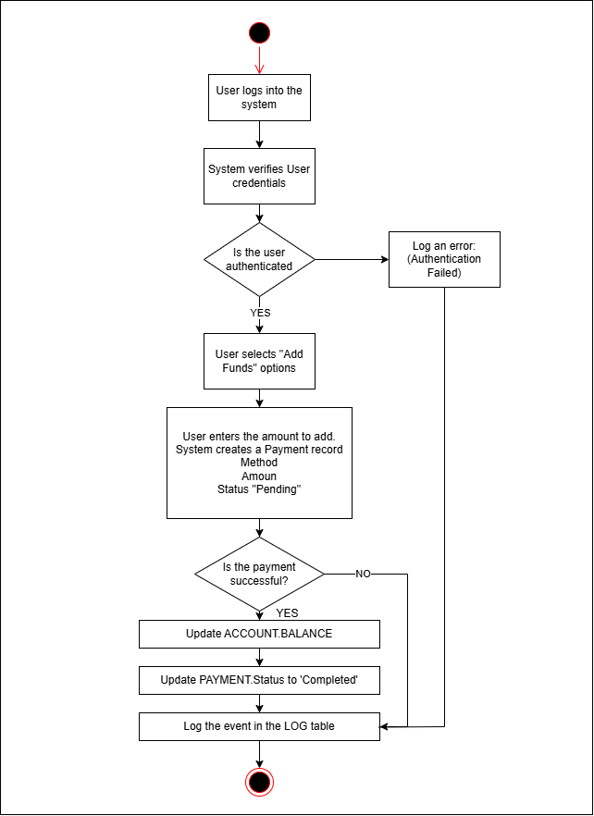
4. Log Management (Error Handling)
This process describes how the system logs events or errors.
- Start: An event or error occurs in the system (e.g., unreadable plate, payment failure).
- Action: System identifies the event type.
- Action: Create a new LOG entry.
  - Attributes: LogID, LogType (e.g., "Error", "Info"), Message (e.g., "Unreadable Plate"), TimeStamp.
- Action: Store the LOG entry in the database.
- End: Event logged successfully.

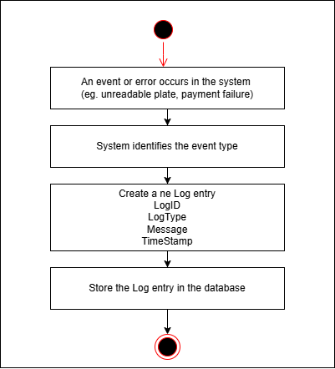

5. Camera Status Monitoring
This process monitors the status of cameras in the tolling system.
- Start: System initiates a status check for all CAMERA entities.
- Action: Loop through each CAMERA in the system.
- Action: Check CAMERA.Status.
  - Decision: Is the camera active?
    - Yes: Proceed to next camera.
    - No: Log an error in the LOG table (e.g., LogType = "Camera Failure", Message = "Camera Offline").
- Action: Notify admin (via Email) if any camera is offline.
- End: Camera status check completed.

